THE
HORMONAL
MAIL
THE OFFICIAL QUARTERLY NEWSLETTER OF CLASSIC LIVESTOCK MANAGEMENT
SERVICES.

VOLUME 1. NO.19.
JANUARY 2011

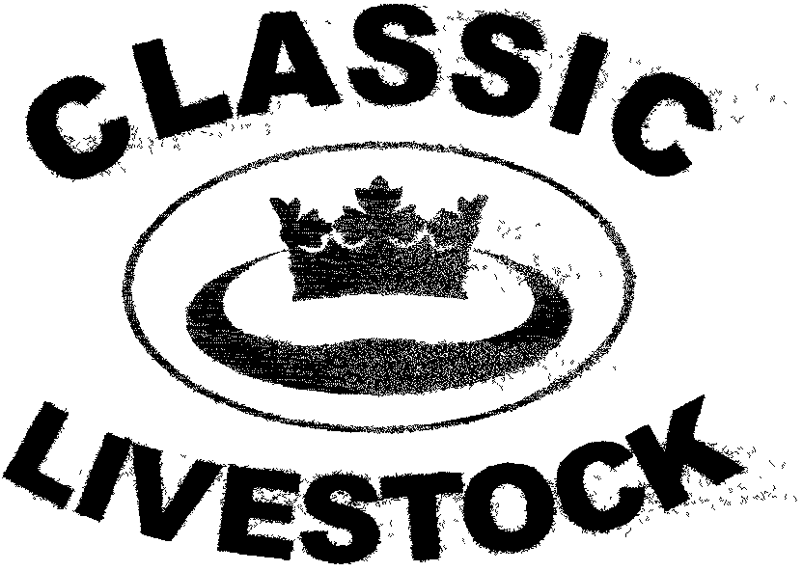

ACN 092435571
P.O. BOX 1181, PHONE: 0741297029/0411201879.
MARYBOROUGH, QLD. 4650.
Email:gewyatt@bigpond.com
Website:www.classiclivestock.com
EDITORIAL.
I would like to take this opportunity to wish everyone a prosperous, peaceful and satisfying New Year as we enter 2011. No doubt you will continue to experience the ups and downs in life and it is my wish that your ups outweigh the downs this year. I hope that you can all achieve some very desirable goals throughout the year. It is certainly our company’s aim to have its most successful year to date. I am now concentrating all the time that is needed to give the company every opportunity to grow and move ahead this year. I have resigned from my previous role to focus more on the evaluation business and I am hoping for your support during this coming year so that we can work together to get the cattle industry back on track in regard to breeding for quality rather than just quantity. Plenty of publicity continues to be given by the industry on working towards breeding for quality and millions of dollars continues to be soaked up in so called research to discover the keys to breeding quality meat.
This, of course, continues to be of huge frustration to our company when the answer is staring the experts in the face. It is what we have known and been promoting now for the last 10 – 12 years and based on our lifetime of experience in the industry. Because what we know as the facts to producing quality are simple, straight forward and would not require millions of dollars to put in place, the industry can’t seem to accept that it might just work. The saddest point about this whole saga is that many good, hardworking, conscientious producers are being hoodwinked into believing the gilt edged rhetoric being fed to them by so called industry “leaders” and large companies who benefit from the funds coming from the government “cash cow” for research etc.
NATURE’S WAY
We are continuing to get very unseasonable rainfalls in many areas of Eastern Australia, which would normally be very welcome if they were coming in moderation, but in the last few weeks of 2010 that moderation became a deluge.
Our hearts go out to those many producers who have been battling drought or near drought conditions for the last 10 years or so, especially in the grain industry and were finally starting to look forward to near record harvests a couple of months ago and are now looking at such huge losses. Many crops are just to wet to get headers onto the paddocks and even those that can harvest are suffering quality downgrades for their grain because of the weather damage.
I travelled from my home here in Maryborough in Qld. to Melbourne in Vic. in late November, as I have done regularly over the last 15 – 20 years and it is the first time that I have seen green grass all the way. There are normally some very dry areas but not this time. I could see the bumper grain crops virtually all the way, but few harvesters working. In fact we ran into several rain periods on the way. There were paddocks where the harvest had started, but the wheel tracks in the crop had indicated that the headers had become bogged and harvesting had to stop.
Whilst these conditions have led to such a devastating blow to the cropping industry, the grazing industry is in a position to recover more quickly from the flood conditions that it has been experiencing. There have certainly been some significant stock losses in the many flooded areas and when the flood waters recede, which will not be for some time in some areas, there should be a good response from pastures if they have not been to water logged. This will put the cattle and sheep industry in a good position for the next few months at least. There will also be an increase in the feed grain available because of the downgrading of so much wheat etc. that will benefit feed lotters so this should result in lower feed grain prices for the next year or so. I guess when some lose there are others who win. That seems to be the nature of agricultural industries world wide.
Still, that doesn’t decrease the pain that nature’s course plots for us and for those who are suffering at the moment our thoughts are with you. I would like to encourage those affected by the current seasonal conditions and who are facing some tough times ahead to please take the time to talk about what is happening for you with others whether they be family, neighbours or professionals.
Fortunately, there is a slowly growing recognition in rural communities that farmers go through the same or similar emotional cycles as everyone else and deserve the same support that has been available in cities for many years. The worst thing that you can do if you are feeling crushed by recent events is to withdraw into yourself, even when it seems that would be the best option for you or it is all you have ever known how to do. If it hasn’t worked in the past, then it is unlikely to now. There are others out there who can support you in a range of different ways and it is not a sign of weakness etc. to ask for support. It is also an opportunity to give others a sense of fulfilment by asking them to support you. There is every chance the boot will be on the other foot at some stage during your life. To graciously accept a gift of support is just as important as giving when others are in a time of need.

GETTING TO CHANGE
We’ve discussed change a bit in other newsletters so I thought I would just add a few more thoughts here and possibly explore them a little bit further. Quite often the biggest hurdle in the whole change process is the decision to actually make a change or changes, or even before that, to actually realise that things could be better than they are now and that you do actually have the power to consider other options. Once it has been decided that the current direction or path is not the best for you and that you need to do something different, then whilst finding that other option or options may seem somewhat daunting, it is not as difficult as the actual initial recognition that you need to do something different.
Most of us have experienced how difficult it is to get a vehicle wheel out of a deep rut in the road or track we are travelling. It just doesn’t seem like there is any way out and to try and veer out is exhausting and usually the vehicle doesn’t respond because it is in to deep or hasn’t the power to turn itself out.
Quite often, that is what it is like in our lives. We just get into the same old routine and little if anything changes. Try looking at the real big picture of your own life span and start to work out how long you have been doing what you have become dissatisfied with and when did you first start to feel this way. It takes a lot to even get to the stage where you realise that what you are doing could be done differently to give a better outcome. This applies to all or any aspect in your life whether it be personal or with your business. Some people are fortunate in that they have the type of personality that is always naturally looking for other ways to do things. Creativity is one of their main values. When they are in the rut they usually decide that stopping right where they are until they can find whatever it is in the form of a spade to get them out of it is a better option than just keeping on going and getting deeper into the rut. However, there are many others who don’t have this type of personality and so have varying degrees of difficulty in recognising the possible opportunities that are passing them by. Usually, it requires a major life changing event to motivate most of us into considering other options. Others just never see any of these other possible options. Still others use all their energy making excuses as to why they don’t need to change. Working with this last group is probably the most frustrating experience because often that energy used on the excuses would be far better directed at considering what might happen if they did do things differently.
Having said all that, it must be acknowledged that other people are happy with where they are and doing what they are doing for the rest of their lives and that may well be fine in some circumstances.
However, if you are running a business in today’s world, you are in a competitive environment and need to be doing things very well just to survive. Usually to just keep doing the same thing day in and day out means that you are actually losing ground and going backwards.
Often the main challenge these days with the increasing number of options available in business is finding the one that best fits your particular enterprise. Do you do what the experts tell you is going to work or do you do your own thing, or maybe take some of each and combine them? To get a full sense of satisfaction out of change, it is usually necessary to have some of your own input into decisions. That is important because it gives you a return on the personal energy you have used in getting the best outcome for your business, i.e. energy you have used in going through the whole change process and rest assured that it will take more energy than most people are aware of.
Just considering this in light of our own business and the observations we have made when working with producers, it is frustrating when attempting to introduce our system to experience negativity towards it because it is different in some respects and hasn’t necessarily got a lot of scientific evidence behind it. What it has got though, is a lot of animal common sense and decades of practical observation and management. It is not only breeders and producers who would just prefer to keep doing the same things they have always done or told to do by industry gurus and slick marketers. In trying to establish a production chain from producer to consumer, we are coming across a similar approach from processors and butchers. They are prepared to listen to our plans and agree that they sound workable, but really, they haven’t the time to be involved because they are too busy trying to make a living. The real frustration comes about when they don’t understand that it won’t cost them any more to process or market our guaranteed graded quality product than it does currently for a product that they really don’t know what quality it is. In fact, ultimately they will be better off because the demand for the product will increase as the public become aware that such and such a butcher at such and such a place has the best meat.
We are certainly not saying that our system is foolproof or is for everyone. However, it is an extremely viable option that can no longer be ignored and is an option that we are asking everyone in the industry to consider when they are contemplating change.
*******************************************************

RETAIL FALLOUT
We are currently seeing a situation in beef marketing in Australia that should be concerning all producers. The two major supermarkets here have slashed their meat prices in recent months. Cole’s decision to sell only HGP free beef is one that we do favour although at the same time being aware that the use of these implants is often the difference in profit or loss for feedlots. In retaliation to this Coles decision in September, Woolworths immediately cut prices on some 27 lines of cuts. Then, of course, Coles has followed suit by reducing prices on a range of their lines.
Now, who is going to pay for these price cuts?
The supermarkets have issued remarks that they were going to absorb the current higher livestock cost and invest in lower shelf prices to maintain and increase consumer demand.
Any one who has dealt with these supermarkets in a marketing capacity know that their buying policies are very flexible usually in their favour. So if producers think that any beef price war will be in their interest then they are living in another world and should consider their future in the industry. Ultimately, breeders/producers will lose out. The other losers will be the small independent butchers
caught in the middle of this price war. They will just not be able to compete with the major retailers who attract the bulk of the population.
Just as a matter of interest, to give you an idea of the cost of getting meat to the retail stage, our estimation is that it costs around $7.00+ per kg. Now, there may be some processors who can do it slightly better than that because of economies of scale, but generally speaking, we believe this to be a realistic figure on today’s livestock prices. So when you are buying meat, you will get an idea of what the cost price is. So if mince is $4/kg., then the top cuts would need to be $20.00 plus for the retailer to break even depending on the bone our percentage for each particular carcase.
Again this highlights how little control the majority of producers actually have over what they are paid for their input into each kg. of what they produce. Whilst some producers have been able to find their own niche markets or form a cooperative to do the same, this only accounts for a very small percentage of the beef produced in the world.
In the last newsletter, we discussed bone out yields and we believe this is one of the glaring areas where producers could start to recuperate a fairer return for their product.
Another area is in the production of a higher quality product on a consistent basis. This basically gets back to breeding and the following article offers some thoughts on the current situation and what changes may have a significant impact on improving quality and consistency.
*******************************************************
MORE ON CONSISTENT BREEDING.
These comments are not breed specific as we have indicated regularly, breed is a personal choice and the CLMS system does not discriminate between breeds.
We believe strongly that despite publicity and marketing hype coming out of breed societies, the Australian, and for that matter the world, cattle breeding industry is in turmoil.
There have never been as many breeds available to producers to choose from as there are today. It would be interesting to research how many new breeds have evolved over the last 50 years. Breeds such as Charbray, Braford, Senegray, Brangus, Belmont Red, Droughtmaster and the list go on are all recent additions to the stud books. These are all breeds that have been derived from crossing 2 or more other breeds. I would like some one to tell me what advantages any of these breeds have that stand out against other breeds, especially those that have been around for more than 200 years. Certainly, in some isolated cases, one of these crossbreeds may be more suitably adaptable to a certain environment, but can anyone tell me how any of these breeds have actually improved the quality of meat available to consumers or the consistency of the product.
Clearly, today, the factors that decide whether a breed is popular or not is firstly, the marketing organisation behind the particular breed and secondly, what is the flavour of the month for the large feed lots and processors, not the name it has earned over years for producing a good, high quality and consistently tender product. The breeds that are popular with the feed lots and processors are the ones that they can get the most out of in terms of saleable meat yield whilst being able to pay the producers the least. So, as we explained in the last newsletter, in regard to saleable meat yield, the cattle that have the highest meat to bone ratio will be the ones the processors want because they are only paying on dressed weight as a rule.
The current trend in breeding direction only serves to highlight the desperate state that the industry is currently in. It shows an industry that has no direction and is breeding aimlessly in the hope that one day one of these cross breeds or similar will be the one to lay the proverbial “golden egg”. If you study the results of all the experimental breeding over the last 50 + years, then realistically, this is not going to happen.
The most effective way for the industry to get back on its feet is to totally reverse the current direction because it clearly isn’t working.
The policy of crossing and crossing more and more is not going to produce consistency, even of poor quality. The only advantage of cross breeding is for hybrid vigour and then the resultant animals need to be terminated. The other factor with cross breeding is that the less stable genetically the foundation parents of the two breeds being crossed is, the less likely for there to be a high percentage of their offspring showing the true hybrid vigour characteristics.
So, what would it need to reverse the current direction?
It would need breeders and their marketing mouthpieces to take a cold hard look at their personal egos and start to put the future of their industry at the top of their priorities because if they don’t, the industry is only going to get sucked further into the quicksand and eventually be “bought out” by big business and multi nationals with their core vested interests being in other businesses.
The industry could do far worse than focus on identifying the very best of the best in each breed and then line breeding within these foundation herds to ensure that the right genes are selected for to produce quality and consistency.
In the next edition of the newsletter, I will talk more about line breeding. I will also discuss another breed for our section on breeds that lack of room has meant I could not include this time.
*******************************************************
UPDATES.
I would like to take the opportunity to wish Gearld Fry a speedy recovery from his recent knee replacement surgery. Knowing Gearld’s enthusiasm for his work, I don’t think it will be long before we see him back on the trail again. Our thoughts and prayers continue to be with both Gearld and his wife Margie as they continue to meet their health challenges in such a positive and proactive way that serves as a motivation to us all.
Our thoughts are also with the Williams family as Ben continues his recovery from his helicopter accident while mustering cattle in the Northern Territory and for John, his father and one of our shareholders, as he recovers from a stroke earlier this year.
*******************************************************
MAILING LIST
I would like to apologise to anyone who has been on our mailing list but has not received the last newsletter. I only have the usual excuse of blaming the computer. We changed computers and upgraded our email program (I think) a while ago and lost some of the mailing lists so I know that some of you are no longer on our lists. If you are reading this from our website and would like to be included or re-included on our lists I would be grateful if you could email me your details. Again, my apologies for any inconvenience.
*******************************************************
Thank you for your continued interest in our newsletters, our website and our book. Please feel free to order one of our books and become familiar with the CLMS system and the directions we are taking in the overall scheme of animal and food production for human consumption
PLEASE FEEL FREE TO CONTACT US ABOUT ANY ITEMS IN THIS NEWSLETTER, ON OUR WEBSITE OR IN OUR NEW MANUAL. WE WELCOME PRODUCER INPUT AND INTEREST AND WANT TO INVOLVE YOU IN WHAT WE ARE DOING.
Disclaimer: - Information contained in this newsletter is believed to be true and accurate at the time of publication. Classic Livestock Management Services is not liable to any person or organisation, whether in negligence or other wise for anything published or omitted from this publication.

